**A**

**PROJECT REPORT**

ON

**ExploreMate**

Submitted in partial fulfillment for the award of

**Post Graduate Diploma in Advance Computing**

**(PG-DAC) from**

**INSTITUTE OF EMERGING TECHNOLOGIES**

**Authorized Training Centre**



**Under the Guidance of**

**Name of the Guide**

**MRS . Sampada Tarare**

**BY**

Mr.Sarvesh santosh Kulkarni (240845920078)

Mr.Mahesh gopal chauthe(240845920043)

Ms.Gitanjali patil(240845920057)

Ms.Vaishnavi Ramkrishna Gawande(240845920095)

Mr.Ajinkya Vijay Katrale (240845920037)



**CERTIFICATE**

This is to certify that the project report entitled **Explore Mate** is a bonfire work carried out by **Sarvesh santosh Kulkarni,Mahesh gopal chauthe,Gitanjali patil,Vaishnavi Ramkrishna Gawande,Ajinkya Vijay Katrale**,andsubmitted in partial fulfilment ofthe requirement for the C-DAC ACTS, DAC course in **Institute of Emerging Technology** in the batch of **Aug 2024**.

**Course Coordinator** **External Examiner**

**ACKNOWLEDGEMENT**

This project **Explore Mate** was a great learning experience for us and we are submitting this work to Advanced Computing Training School (CDAC).

We are very glad to mention the **MRS . Sampada Tarare** for her valuableguidance to work on this project. Her guidance and support helped us to overcome various obstacles and intricacies during the course of project work.

Our most heart full thanks goes to ***Mr. Sangram Patil*** **(Director ,IET)**who gave all the required support and kind coordination to provide all the necessities like required hardware , internet facility and extra lab hours to complete the project and throughout the course up to the last day here in C-DAC ACTS, Pune.

Sign of student

Mr.Sarvesh santosh Kulkarni (240845920078)

Mr.Mahesh gopal chauthe(240845920043)

Ms.Gitanjali patil(240845920057)

Ms.Vaishnavi Ramkrishna Gawande(240845920095)

Mr.Ajinkya Vijay Katrale (240845920037)

**Abstract**

ExploreMate is an innovative travel application aimed at redefining the way people experience travel by bridging the gap between travelers and professional tour guides. The platform combines personalization, interactivity, and convenience to create seamless travel planning and immersive experiences.

ExploreMate provides users with the ability to discover, connect, and book expert guides who offer tailored itineraries, local insights, and interactive tours. The application integrates advanced technologies such as real-time communication, and geolocation to enhance user engagement and decision-making.

Key features include personalized trip suggestions, live chat with guides, and an easy-to-navigate booking system. Additionally, ExploreMate promotes cultural exchange by fostering direct interaction between travelers and locals, offering an authentic and enriching travel experience.

**Index**

|  |  |  |
| --- | --- | --- |
| **Sr. No.** | **Title** | **Page No.** |
| **1** | Introduction | 6 |
| **2** | Problem Definition & Scope | 7 |
| **2.1** | Problem Definition | 7 |
| **2.2** | Goals & Objectives | 8 |
| **2.3** | Major Constraints& Outcomes | 11 |
| **3** | Software Requirement Specification | 29 |
| **3.1** | Purposed System | 29 |
| **3.2** | Scope | 30 |
| **4** | System Modules | 31 |
| **5** | Performance-Requirements | 32 |
| **5.1** | H/W Requirements & S/W Requirements | 39 |
| **6** | UML Diagram | 46 |
| **6.1** | DFD | 46 |
| **6.2** | ERD | 47 |
| **6.3** | Use case diagram | 48 |
| **6.4** | Class Diagram | 49 |
| **6.5** | Sequence diagram | 50 |
| **6.6** | Activity Diagram | 51 |
| **6.7** | Deployment diagram | 52 |
| 6.8 | System Architecture | 53 |
| **7** | Test Cases | 54 |
| **8** | Screenshots | 56 |
| **9** | References | 59 |

**1 Explore Mate**

* **Introduction**

Traveling is about more than just visiting destinations; it’s about creating meaningful connections, discovering hidden stories, and immersing yourself in the richness of local culture. **ExploreMate** is here to revolutionize your travel experience, making every journey more engaging, seamless, and memorable.

ExploreMate is a cutting-edge travel platform that brings together technology and expertise to cater to every kind of traveler. The app connects users with professional tour guides, allowing them to explore the world with confidence and ease. Whether you're an adventure enthusiast, a history buff, or a nature lover, ExploreMate offers tailored recommendations to match your unique interests and preferences.

Designed for convenience and personalization, ExploreMate offers features that redefine how you plan, enjoy, and remember your trips. You can create a detailed profile to receive curated suggestions, set preferences like budget, tour type, or language, and browse a wide range of expert tour guides. Dive into comprehensive guide profiles, compare reviews, chat with guides, and book tours directly within the app.

ExploreMate doesn’t stop at planning—it enhances your journey in real-time. Use live tracking to follow your itinerary, chat with your guide for instant support, and enjoy interactive activities like scavenger hunts or photo challenges. For those seeking exclusive experiences, ExploreMate offers customizable tours and access to hidden gems, ensuring you explore destinations in a way that’s both authentic and unique.

After your trip, the journey continues. ExploreMate provides tools for you to share your experiences, from uploading photos and videos to writing reviews or creating a personalized travel journal. Recommend guides, inspire your friends, and relive your adventures anytime through the app.

For travelers with complex itineraries, ExploreMate simplifies multi-destination and multi-day trip planning, bundling accommodations, transportation, and tours into convenient packages. Need help along the way? The app’s robust customer support, live chat, and FAQ resources are just a tap away.

Whether you're traveling solo, planning a group tour, or embarking on a family adventure, ExploreMate ensures that every aspect of your journey is smooth, tailored, and unforgettable. Say goodbye to the hassles of traditional travel planning and hello to a world of possibilities with ExploreMate—your trusted travel companion.

**Problem Definition**

* 1. **Purpose**

### Purpose of the Project

The purpose of ExploreMate is to empower travelers by simplifying the way they plan, experience, and relive their journeys. By bridging the gap between explorers and professional tour guides, ExploreMate aims to provide personalized, authentic, and enriching travel experiences tailored to individual interests and preferences.

Through its intuitive platform, ExploreMate seeks to:

1. **Facilitate Seamless Travel Planning**: Streamline the process of discovering, comparing, and booking tour guides and experiences, making travel planning effortless and efficient.
2. **Enhance Exploration**: Provide users with access to local expertise, hidden gems, and immersive activities that go beyond typical tourist experiences.
3. **Foster Personalization**: Offer customized itineraries and recommendations based on user preferences, ensuring every journey feels uniquely tailored.
4. **Support Interaction**: Enable real-time communication between travelers and guides for a smooth and connected travel experience.
5. **Promote Cultural Exchange**: Encourage meaningful connections between travelers and local communities, fostering appreciation and understanding of diverse cultures.
6. **Create Lasting Memories**: Help users document, share, and relive their adventures through travel journals, professional photography services, and social sharing features.

At its core, ExploreMate exists to transform travel into a more fulfilling, interactive, and stress-free experience, inspiring people to explore the world with confidence and curiosity.

**1.2 Scope**

ExploreMate is a comprehensive travel platform designed to enhance the travel experience by connecting users with professional tour guides and offering personalized, interactive, and streamlined planning tools. The app’s scope covers the entire journey of a traveler, from initial planning to post-trip reflection, ensuring a seamless and engaging experience.

### Functional Scope

**User Access and Profiles**:

* 1. Account creation and login options, including guest access.
  2. Personal profile setup with customizable preferences for tailored recommendations.

**Personalized Recommendations**:

* 1. Filtered search for tour guides based on preferences such as budget, language, expertise, and transportation mode.
  2. Suggestions for tours and guides tailored to user interests.

**Guide Profiles and Bookings**:

* 1. Detailed guide profiles with biographies, reviews, pricing, and available tour options.
  2. Real-time chat with guides for inquiries.
  3. Instant booking and secure payment integration.

**On-Tour Features**:

* 1. Live trip tracking with navigation to key destinations.
  2. Interactive tour elements, such as local recommendations, scavenger hunts, and photo challenges.
  3. Real-time communication with guides during the trip.

**Post-Tour Engagement**:

* 1. Review and rating system for guides and tours.
  2. Media upload for sharing photos, videos, and travel stories.
  3. Personalized travel journal for documenting and reliving experiences.

**Advanced Features**:

* 1. Multi-destination and multi-day trip planning with bundled services like accommodation and transportation.
  2. Customizable group tours and itineraries for families and friends.
  3. Professional photography services and access to hidden, local-recommended spots.

**Customer Support and Notifications**:

* 1. 24/7 live chat and FAQ resources for assistance.
  2. Notifications and reminders for bookings, upcoming tours, and special offers.

### Technical Scope

**Platform Accessibility**:

* 1. Availability on mobile platforms (iOS and Android).
  2. Cloud-based infrastructure for seamless synchronization across devices.

**Data Integration**:

* 1. AI-powered algorithms for personalized suggestions.
  2. Secure storage of user data and payment information.

**Localization**:

* 1. Support for multiple languages to cater to a global user base.
  2. Filters for local guides, events, and attractions based on the user’s location.

**Scalability**:

* 1. Ability to accommodate an increasing number of users, guides, and tours.
  2. Flexible architecture to integrate additional features and services in the future.

### Market Scope

1. **Target Users**:
   1. Solo travelers, families, groups, and corporate teams seeking tailored travel experiences.
   2. Local and international travelers looking for authentic cultural, historical, or adventure experiences.

**Target Regions**:

Initial focus on popular travel destinations, expanding globally based on demand and partnerships with local guides.

**Tour Guide Community**:

A platform for professional and certified guides to showcase their expertise and expand their reach.

**Travel Ecosystem**:

Partnerships with local service providers for accommodations, transportation, and dining to offer bundled packages.

### Limitations

* ExploreMate focuses primarily on guided travel experiences and does not handle independent travel logistics like flight bookings.
* The availability of certain features may depend on the user’s location and the local guide network.

**Conclusion**  
The scope of ExploreMate encompasses all aspects of travel, ensuring that users have a comprehensive tool to plan, experience, and relive their journeys. With its expansive features and emphasis on personalization and engagement, ExploreMate aims to redefine modern travel for both explorers and guides alike.

**1.3 Definitions, Acronyms, and Abbreviations**

1. **User**: Any individual who interacts with the ExploreMate platform, including travelers and guides.
2. **Traveler**: A user of ExploreMate seeking guided tours and travel experiences.
3. **Guide**: A professional tour guide offering personalized travel services through ExploreMate.
4. **Profile**: A digital representation of a user, containing details such as preferences, reviews, and personal information.
5. **Tour**: A planned travel experience or journey guided by a professional, available for booking on ExploreMate.
6. **Itinerary**: A detailed schedule of activities, destinations, and services for a specific tour or trip.
7. **Hidden Gems**: Unique, off-the-beaten-path attractions or experiences recommended by guides or locals.
8. **Interactive Content**: Engaging activities provided during tours, such as photo challenges or scavenger hunts.
9. **Multi-Day Tour Package**: A bundled offering that includes multiple tours, accommodations, and other travel-related services spanning several days.

#### ****Acronyms and Abbreviations****

1. **FAQ**: Frequently Asked Questions.
2. **UI**: User Interface – the part of the app through which users interact with ExploreMate.
3. **UX**: User Experience – the overall experience of users when using the app.
4. **API**: Application Programming Interface – a set of tools and protocols for building software applications, used for integrating ExploreMate with external systems or services.
5. **GPS**: Global Positioning System – technology enabling live tracking and location-based features in the app.
6. **PWA**: Progressive Web Application – a web-based app that provides a mobile-like experience.
7. **OTP**: One-Time Password – a security feature used during login or payment authentication.

#### ****Abbreviations****

1. **ExploreMate**: Refers to the app and platform itself.
2. **TourOps**: Tour Operations – encompasses all activities related to organizing and conducting tours.
3. **LiveTrack**: The feature within ExploreMate that enables real-time tracking during tours.

**1.4 Overview**

ExploreMate is a next-generation travel application designed to transform how users discover, plan, and experience their journeys. By leveraging technology and local expertise, ExploreMate connects travelers with professional tour guides and offers a platform rich with features to create immersive and personalized travel experiences.

ExploreMate addresses the challenges of traditional travel planning, such as finding reliable guides, building tailored itineraries, and ensuring a seamless travel process. The platform simplifies these tasks through a user-friendly interface, advanced recommendation algorithms, and robust features that cater to both casual and experienced travelers.

With ExploreMate, users can:

* Browse and book expert tour guides based on preferences like budget, language, and type of tour.
* Customize itineraries to align with their unique interests and needs.
* Access real-time interaction tools during tours for a connected experience.
* Relive and share their travel memories through journals, photos, and reviews.

ExploreMate’s functionality extends to tour guides, enabling them to showcase their expertise, connect with a broader audience, and grow their business. By providing a platform for collaboration, ExploreMate bridges the gap between travelers and local communities, fostering authentic and enriching experiences.

#### ****Key Features****

* **Personalized Travel**: Customizable preferences for tailored recommendations, including tour type, budget, transportation, and language.
* **Comprehensive Search**: Tools to discover and compare professional tour guides based on reviews, expertise, and availability.
* **Real-Time Interaction**: Live tracking, in-app chat, and interactive tour elements for seamless communication during trips.
* **Post-Trip Engagement**: Rating, reviews, and a travel journal to document and share memories.
* **Advanced Planning Options**: Multi-day tour packages, group tours, and multi-destination itineraries.

#### ****Target Audience****

ExploreMate serves a diverse range of travelers:

* Solo travelers seeking personalized experiences.
* Families and groups planning collective tours.
* Corporate teams requiring organized itineraries.
* Adventure seekers, cultural enthusiasts, and casual tourists alike.

#### ****Unique Value Proposition****

ExploreMate goes beyond traditional travel apps by combining advanced technology with human expertise. It provides users with access to local insights, hidden gems, and customizable tours, making travel both convenient and meaningful. Whether for a day trip or an extended vacation, ExploreMate ensures every aspect of the journey is thoughtfully designed and effortlessly executed.

#### ****Vision****

To create a world where travel is accessible, personalized, and enriched by meaningful connections with local cultures and communities.

#### ****Mission****

ExploreMate is committed to enhancing the travel experience by offering innovative solutions that connect travelers with guides and services, empowering them to explore the world with ease and confidence.

1. **Overall Description**

**ExploreMate** is an innovative travel application designed to enhance the way travelers explore the world. It serves as a platform that connects users with expert, local tour guides, offering personalized, seamless, and interactive travel experiences. ExploreMate goes beyond basic tour bookings by enabling users to customize their travel itineraries, interact with guides in real-time, and relive their journeys with photos, videos, and reviews.

#### ****Key Features****

* **Personalized Travel Experience**: By gathering preferences such as tour type, budget, language, and transportation options, ExploreMate curates customized suggestions for guides and tours, ensuring each user’s travel experience is tailored to their unique needs and interests.
* **Professional Guides and Expertise**: Users can explore a wide variety of guides with specialized expertise in areas like history, culture, adventure, and nature. The app provides detailed profiles, including reviews, pricing, and available tours, making it easy to find the perfect match.
* **Interactive and Real-Time Tour Management**: During tours, users can enjoy features like live tracking of their location, chat with guides, and interactive content such as scavenger hunts, local recommendations, and photo challenges.
* **Booking and Payment Integration**: The app allows users to book tours directly with their chosen guides, providing a secure and straightforward payment system. Users can also opt for additional services, such as transportation and meals, as part of their booking.
* **Post-Trip Engagement**: After completing a tour, users can rate and review their experiences, upload photos or videos, and share their adventures with the ExploreMate community. This feature encourages social interaction and allows travelers to document their journeys.
* **Multi-Destination Planning**: For travelers with more complex itineraries, ExploreMate supports multi-destination planning and booking, offering bundled services like accommodations, meals, and transportation.
* **Group and Customizable Tours**: ExploreMate offers customizable group tours, allowing families, friends, or corporate teams to organize unique experiences and itineraries together.
* **Travel Journal**: Users can create a personal travel journal to document their experiences, share them with friends, or keep them as cherished memories.

#### ****Platform Access and Scalability****

ExploreMate is available on both iOS and Android devices, with a cloud-based infrastructure ensuring smooth and synchronized access across multiple platforms. The app is designed to scale easily, supporting a growing number of users, guides, and destinations. As the app expands globally, it will incorporate a variety of languages and regional-specific content, further enhancing the user experience.

#### ****Target Audience****

ExploreMate is designed for:

* **Solo Travelers**: Individuals seeking a more personalized, independent travel experience.
* **Families and Groups**: Those who wish to organize shared tours with custom itineraries.
* **Corporate Clients**: Teams or businesses requiring well-planned travel arrangements for work-related events or team-building experiences.
* **Adventure Seekers and Cultural Enthusiasts**: Travelers looking to dive deeper into a destination’s history, culture, and hidden gems.
* **First-time Travelers**: People who are new to travel and are seeking guidance and support for navigating unfamiliar destinations.

#### ****Business Model****

ExploreMate operates on a commission-based model, where the platform charges a small fee on each booking made through the app. This fee is shared between the platform and the guides. In addition, ExploreMate offers premium services such as professional photography, special tour packages, and travel bundles for added convenience.

#### ****Conclusion****

ExploreMate is a comprehensive solution for today’s traveler, offering not only the convenience of booking tours and experiences but also the personalization and flexibility that modern explorers desire. Whether you’re looking for a guided day trip, a multi-day adventure, or an authentic cultural experience, ExploreMate ensures that your travel journey is seamless, enjoyable, and unforgettable.

**2.1 Product Perspective**

ExploreMate is a cutting-edge travel application that redefines how users plan, experience, and share their travel journeys. Positioned as a user-friendly and customizable travel platform, ExploreMate bridges the gap between technology and local expertise, allowing users to connect with professional tour guides and enjoy personalized, seamless travel experiences.

The app operates within a broader travel ecosystem, incorporating elements such as local insights, professional guidance, real-time communication, and an interactive, social-sharing experience. ExploreMate’s vision is to empower travelers with all the tools they need to make informed, dynamic, and meaningful travel decisions, while simultaneously giving tour guides a platform to expand their reach and showcase their expertise.

#### ****Key Relationships and Integrations****

ExploreMate operates within the following contexts:

* **Users (Travelers)**: The primary audience for ExploreMate. Users have the ability to search for, book, and review tours and experiences. The app provides tailored recommendations based on user preferences and profiles.
* **Tour Guides**: Professional guides who create profiles, list available tours, and interact with users. ExploreMate offers guides a direct channel to a larger audience while also providing tools to manage bookings, tours, and customer relationships.
* **Third-Party Services**: ExploreMate integrates with external services for payment processing, location tracking (GPS), and other features like professional photography and transportation services.
* **Local Businesses and Service Providers**: ExploreMate has potential partnerships with local businesses such as hotels, restaurants, and transportation services, allowing users to book these services along with their tours for a seamless experience.

#### ****Product Features in the Ecosystem****

1. **Search and Recommendation System**: Leveraging AI and user preferences, ExploreMate’s search functionality connects users to the right guides and tours, offering recommendations for unique experiences.
2. **Customizable Itineraries**: Users can personalize their itineraries by selecting the type of experience, budget, tour duration, transportation preferences, and language.
3. **Interactive Tour Features**: The app supports real-time communication between travelers and guides, live tour tracking, and engaging activities like scavenger hunts, photo challenges, and local tips.
4. **Payment Gateway**: ExploreMate integrates with a secure, user-friendly payment system to handle bookings and purchases for additional services.
5. **Social Sharing & Reviews**: After the tour, users can share their experiences, post reviews, and recommend tours to others via social media or within the app’s community.

#### ****Technology Stack and Platform****

ExploreMate is built using modern technologies to ensure scalability, security, and smooth user experience across various devices.

* **Cloud Infrastructure**: Cloud-based data management ensures that user data, tour information, and app content are accessible and synced seamlessly across devices.
* **Geolocation Services**: GPS functionality supports real-time tracking during tours and helps users find guides based on location.

#### ****Market Positioning****

ExploreMate stands out from traditional travel apps by offering a highly personalized, immersive, and interactive travel experience. Unlike generic platforms that focus solely on booking services, ExploreMate focuses on creating a holistic travel journey, integrating local guides’ expertise and ensuring that each trip feels authentic and tailored.

The app caters to users seeking a deeper connection with the destinations they visit, offering not just tours, but cultural, historical, and adventure experiences that go beyond surface-level exploration.

#### ****Growth and Expansion****

As the app evolves, ExploreMate plans to expand its offerings and reach by:

* Partnering with more local guides in emerging travel destinations.
* Enhancing the app’s capabilities to include more diverse tours, multi-day packages, and additional user-requested features.
* Broadening its integration with local businesses to provide users with an all-in-one travel service, from accommodation to dining.

ExploreMate’s scalability is built into its core design, and the platform is poised for expansion into new regions and markets, ensuring travelers from all over the world can enjoy seamless travel experiences.

**2.2 Product Functions**

#### ****1. User Account Management****

* **Sign Up/Log In**: Users can create an account or log in using email, social media accounts, or continue as guests. This feature allows personalized experiences, booking history, and recommendations.
* **Profile Creation**: Travelers and guides can create or edit their profiles with personal information, preferences, and preferences for travel experiences.
* **Account Settings**: Users can manage settings for notifications, privacy, and payment methods.

#### ****2. Tour Guide Search and Discovery****

* **Search Functionality**: Users can search for guides based on location, expertise, type of tour (historical, adventure, cultural, etc.), availability, and price.
* **Filter Options**: Filters allow users to refine their search by price range, tour duration, language preference, transportation options, and guide gender.
* **Map Integration**: The app provides an interactive map to help users discover guides and tours based on proximity to their current location or chosen destination.

#### ****3. Personalized Recommendations****

* **Tour Type Customization**: Users can set their preferences for specific types of tours (e.g., nature, culture, food) to receive the most relevant suggestions.
* **Local Insights**: ExploreMate provides insights into local hidden gems and off-the-beaten-path locations recommended by guides.

#### ****4. Tour Booking and Payment****

* **Tour Booking**: Users can select a guide, choose a date and time, and book a tour directly through the app.
* **Payment Gateway**: Secure payment processing through multiple payment methods (credit/debit cards, mobile wallets) for bookings, services, and tips.
* **Add-ons**: Users can add extra services like transportation, meals, or private photography sessions during booking.
* **Booking Confirmation**: Users receive an instant booking confirmation with details such as date, time, meeting point, and tour information.

#### ****5. Real-Time Interaction and Communication****

* **In-App Chat**: Travelers can communicate with their selected guide before, during, and after the tour, asking questions or adjusting tour details.
* **Live Tour Tracking**: A GPS-enabled live map allows users to track their location in real time and follow the guide’s route to the next point of interest.
* **Interactive Content**: During the tour, users can engage in activities like photo challenges, local trivia, or scavenger hunts, making the experience more dynamic and fun.

#### ****6. Post-Tour Engagement and Reviews****

* **Rate and Review**: After completing a tour, users can rate their guide, leave reviews, and share feedback on the overall experience.
* **Photo/Video Uploads**: Users can upload images or videos taken during the tour, adding to their review or sharing them in a community gallery.
* **Recommend to Others**: Users can recommend the guide and tour to their friends, family, or the wider ExploreMate community, increasing the visibility of high-quality experiences.

#### ****7. Multi-Destination Planning****

* **Custom Itinerary Builder**: Travelers can plan trips across multiple cities or destinations, selecting and booking tours for each location.
* **Integrated Services**: The app offers packages that include transportation, meals, accommodations, and activities for multi-day trips, ensuring a hassle-free experience.
* **Journey Management**: Users can manage and track their entire trip from start to finish, keeping all tour and accommodation details in one place.

#### ****8. Group Tours and Customization****

* **Group Tour Management**: Users can organize group tours, invite friends or family, and collaborate on customizing the itinerary, with each participant able to suggest activities.
* **Private Tours**: Users can arrange private, exclusive tours with specific itineraries, tailored to the group’s interests.

#### ****9. Travel Journal and Social Sharing****

* **Journal Creation**: Users can document their travel experiences by creating a digital journal, complete with photos, notes, and videos.
* **Social Media Sharing**: ExploreMate allows users to easily share their experiences and itineraries on social media platforms, or directly with friends through in-app invites.
* **Community Engagement**: Travelers can connect with others in the ExploreMate community, share recommendations, and get inspiration for future trips.

#### ****10. Customer Support and Assistance****

* **Live Chat Support**: In-app customer service chat for immediate assistance with issues such as booking problems, payment issues, or general inquiries.
* **Help Center**: A comprehensive FAQ section that provides answers to common questions and troubleshooting tips for using the app.

#### ****11. Notifications and Reminders****

* **Booking Reminders**: Users receive push notifications to remind them of upcoming tours, including details like meeting points, times, and what to bring.
* **Event Alerts**: The app alerts users about local events, promotions, or new guides in their area.
* **Push Notifications for Offers**: Users can opt into notifications for special offers, deals, or nearby tours that match their preferences.

#### ****12. Security and Privacy****

* **Data Protection**: ExploreMate ensures that all user data, including payment information and personal details, is securely stored and protected.
* **Secure Payments**: The app supports encrypted, secure payment methods for all transactions.
* **Privacy Settings**: Users can adjust privacy settings to control what information is shared, and who can view their profile or journey updates.

**2.3 User Classes and Characteristics**

#### ****1. Solo Travelers****

* **Description**: Individuals who prefer to explore destinations independently and are looking for unique, personalized experiences.
* **Characteristics**:
  + **Personalization**: Value customization options such as personalized itineraries, specific interests, and flexible tour options.
  + **Flexibility**: Seek last-minute bookings, spontaneous tours, and unique travel experiences tailored to their individual needs.
  + **Tech-Savvy**: Often use mobile apps for convenience and prefer apps that are easy to navigate, with minimal time commitment for planning.
  + **Interaction**: Appreciate the ability to communicate with guides directly to ensure tours are tailored to their preferences.
  + **Goals**: To connect with local culture, discover new places off the beaten path, and enjoy personal growth through their travels.

#### ****2. Families and Group Travelers****

* **Description**: Families or groups of friends traveling together who need a more structured and coordinated travel experience.
* **Characteristics**:
  + **Group Coordination**: Need tools for planning and organizing group activities, such as customizable itineraries, group tours, and collaborative trip planning.
  + **Family-Friendly Options**: Prefer kid-friendly tours and activities, accessible transportation, and family-oriented guides.
  + **Convenience**: Look for pre-packaged tours or multi-day options that can be easily booked for all members, ensuring a seamless experience.
  + **Support**: Require extra support through customer service, as group travel often involves more complex logistics (e.g., larger bookings, special accommodations).
  + **Goals**: To bond with family or friends through shared experiences and create lasting memories.

#### ****3. Adventure and Activity Seekers****

* **Description**: Travelers with an interest in exploring extreme activities or natural wonders, such as hiking, trekking, and other outdoor or adrenaline-pumping activities.
* **Characteristics**:
  + **Specialized Interests**: Prioritize unique experiences such as rock climbing, trekking through national parks, or exploring remote destinations.
  + **Detailed Planning**: Want detailed information on safety, equipment, and physical requirements for tours.
  + **High Engagement**: Prefer active participation in their travel experiences, including physical challenges and real-time interactions with guides.
  + **Goals**: To push their physical limits, discover new outdoor adventures, and engage in highly stimulating travel experiences.

#### ****4. Cultural and Historical Enthusiasts****

* **Description**: Travelers with a deep interest in history, art, culture, and local traditions who seek educational and immersive experiences.
* **Characteristics**:
  + **Interest in Learning**: Interested in guided tours focused on history, architecture, local customs, and cultural landmarks.
  + **Detail-Oriented**: Appreciate guides who are knowledgeable and can provide in-depth explanations about historical and cultural aspects.
  + **Preference for Expert Guides**: Want tours led by experienced guides with deep knowledge of local history or cultural heritage.
  + **Goals**: To gain a deeper understanding of the places they visit and experience local culture through stories, artifacts, and heritage.

#### ****5. Luxury and Premium Travelers****

* **Description**: Travelers seeking high-end, exclusive experiences, including private tours, VIP accommodations, and luxury services.
* **Characteristics**:
  + **Customization**: Value personalized, high-end experiences with tailored itineraries, private guides, and premium accommodations.
  + **Exclusive Access**: Prefer to avoid crowded tourist spots and enjoy access to exclusive sites, private viewings, or special services (e.g., professional photography).
  + **Comfort and Convenience**: Expect top-tier service, including luxury transportation, gourmet meals, and accommodations.
  + **Goals**: To have an indulgent, hassle-free experience and enjoy the highest quality services and amenities available during their travels.

#### ****6. First-Time Travelers****

* **Description**: Individuals who are new to traveling and may feel overwhelmed by the planning process. They are often looking for guidance and support to make the experience easy and enjoyable.
* **Characteristics**:
  + **Need for Support**: Value easy-to-follow itineraries, clear information on what to expect, and concierge-level assistance in planning and booking.
  + **Safety and Comfort**: Seek travel experiences that are comfortable and safe, with a focus on popular and well-established tours.
  + **Low Tech Familiarity**: May require more straightforward navigation and explanations within the app, with a focus on user-friendly design.
  + **Goals**: To explore the world with ease and confidence, learning about new cultures while feeling supported by reliable resources and experts.

#### ****7. Business Travelers****

* **Description**: Professionals who travel for business purposes, often looking for convenience, efficiency, and the ability to balance work and leisure during their trips.
* **Characteristics**:
  + **Efficiency-Focused**: Need a fast, easy-to-use app that can help them organize work-related activities and leisure tours without wasting time.
  + **Multi-Tasking**: Appreciate features like group tours for business teams or options for combining meetings with cultural or leisure activities.
  + **Scheduling Needs**: Require precise, time-sensitive booking options to accommodate tight schedules, with the option for last-minute bookings.
  + **Goals**: To mix business and pleasure seamlessly, ensuring productivity while also having time to unwind and experience local culture.

#### ****8. Tour Guides****

* **Description**: Local experts who offer guided tours and share their knowledge with travelers, providing personalized experiences based on their expertise.
* **Characteristics**:
  + **Specialized Knowledge**: Have deep expertise in specific types of tours (e.g., nature, history, adventure) and geographic locations.
  + **Interactive**: Are able to adapt and communicate effectively with users, tailoring tours to meet the interests and needs of different types of travelers.
  + **Customer-Oriented**: Focused on providing excellent customer service, managing bookings, and engaging with users before, during, and after tours.
  + **Goals**: To share their passion and expertise with others, provide enriching experiences for travelers, and build a strong reputation through positive reviews and feedback.

**2.4 Assumptions and Dependencies**

ExploreMate is designed to cater to a wide variety of users, each with distinct needs, goals, and behaviors when it comes to travel. Understanding the different user classes and their characteristics helps ensure that the app delivers tailored experiences for each group. Below are the primary user classes and their defining traits:

### ****2.4 Assumptions and Dependencies****

ExploreMate’s success is built on several assumptions and dependencies, which are critical to the functioning of the app and its features. These assumptions outline the expected environment, user behaviors, and technological requirements for the app's success, while dependencies identify external factors that the app relies on to operate smoothly.

### ****Assumptions****

**Users Have Access to Smartphones**

* + It is assumed that the target users have access to smartphones with internet connectivity, as ExploreMate is a mobile application. The app is designed for iOS and Android platforms, which are the most common operating systems.

**Users Are Familiar with Mobile Applications**

* + The app assumes that most users are familiar with basic mobile app functionality, including account creation, navigation, and in-app purchases. This allows for an intuitive user experience, without the need for extensive tutorials or support.

**Internet Connectivity**

* + It is assumed that users will have access to a stable internet connection (Wi-Fi or mobile data) to fully utilize all features of the app, especially during tour bookings, navigation, and live communication with guides.

**Guide Availability**

* + It is assumed that the registered tour guides are available for bookings at the specified times, and that they possess the necessary skills and certifications to lead the tours they are offering.

**User Engagement**

* + The app assumes that users will engage with the platform, create profiles, and customize their preferences, thereby improving the accuracy and quality of recommendations and interactions within the app.

**Payment Gateway Integration**

* + It is assumed that the app will integrate seamlessly with popular payment gateways (e.g., RazorPay, PayPal) for processing transactions, allowing for secure and smooth payment experiences for both users and tour guides.

**Third-Party Data Providers**

* + It is assumed that the app will have access to third-party APIs or data sources, such as maps, weather services, and local event calendars, to enhance the travel experience and provide up-to-date information to users.

**User Privacy and Data Security**

* + The app assumes that users will trust ExploreMate with their personal and payment information, and that appropriate measures will be taken to ensure data privacy and security according to relevant data protection laws (e.g., GDPR).

### ****Dependencies****

1. **Third-Party API Providers**
   * The app relies on several third-party APIs, such as maps, GPS, weather data, and payment gateways. Any changes, downtime, or issues with these third-party services may affect app functionality.
2. **App Store and Google Play Store Approval**
   * ExploreMate is dependent on the app stores (iOS App Store and Google Play Store) for distribution. Compliance with their respective guidelines and approval processes is necessary for the app to be listed and accessible to users.
3. **Payment Processors**
   * The app depends on reliable payment gateways (e.g., Stripe, PayPal) to handle financial transactions securely. Any issues or disruptions in the services of these payment processors could impact the booking and payment functionalities of the app.
4. **Guide and Tour Provider Data**
   * The app depends on accurate and up-to-date data from tour guides, including availability, pricing, reviews, and other relevant information. If tour guides fail to keep their information current, it could affect the accuracy of recommendations and availability of tours.
5. **Internet Infrastructure**
   * The app depends on reliable internet infrastructure for both users and guides. Poor internet connectivity or network issues can disrupt real-time communication, GPS tracking, and booking processes.
6. **Device Compatibility**
   * ExploreMate relies on devices with adequate hardware and software to provide a seamless experience, including GPS, cameras, and sufficient storage space for media files. Users with outdated devices or software versions may encounter compatibility issues.
7. **Regulatory Compliance**
   * The app depends on compliance with local laws and regulations regarding tourism, data protection, and e-commerce in various regions. Changes in legislation (e.g., new regulations on data privacy, tourism services) could impact app operations or require modifications.
8. **Tourist Destinations and Local Authorities**
   * The app relies on the cooperation of local authorities and tourist attractions to ensure smooth operations, particularly for activities that require permits, special access, or compliance with local tourism regulations.

**Software Requirements Specification (SRS)**

**3. Specific Requirements**

Functional requirements specify the core features and behaviors of the app. These are the operations the system must be able to perform to meet user needs and fulfill business goals.

#### ****1. User Registration and Login****

#### ****Description:** Users must be able to register, log in, or continue as guests to use the app.**

* **Requirements:**
  1. **Sign-Up: Users can create an account via email.**
  2. **Login: Returning users can log in with their email or social media credentials.**
  3. **Guest Access: Users can explore available guides and tours without registering.**
  4. **Password Recovery: Users can reset forgotten passwords through email.**

#### ****2. Profile Creation and Preferences****

* **Description**: Users can create personalized profiles or proceed as guests, setting preferences for a more tailored experience.
* **Requirements**:
  + **Profile Setup**: Users must provide name, photo, and location preferences.
  + **Preference Setup**: Options for tour type, budget, guide gender, transportation, and language.
  + **Save Preferences**: All preferences must be saved to the user profile for future reference.

#### ****3. Search and Filter Tour Guides****

* **Description**: Users should be able to search for available tour guides based on their preferences and tour types.
* **Requirements**:
  + **Search Bar**: Users can enter keywords to find guides by location or expertise.
  + **Filters**: Filters to search by tour type, price range, transportation options, language, and guide availability.
  + **Expertise**: Categories like cultural, historical, adventure, nature, etc.

#### ****4. Guide Profile Management****

* **Description**: Guides must have detailed profiles showcasing their expertise, reviews, and available tours.
* **Requirements**:
  + **Profile Details**: Guides can upload a photo, biography, qualifications, and available tours.
  + **Tour Listings**: Each guide can list available tours with details such as duration, price, and location.
  + **Review System**: Guides will have ratings and reviews from previous users.

#### ****5. Booking and Payment System****

* **Description**: Users must be able to book guides, select tour details, and make payments.
* **Requirements**:
  + **Tour Booking**: Users select a guide, date, time, and tour duration.
  + **Payment Options**: Support for major payment methods (credit card, PayPal, etc.).
  + **Add Extra Services**: Users can add options like meals, transportation, and other extras.
  + **Booking Confirmation**: Once payment is processed, users receive a booking confirmation via email or in-app notification.

#### ****6. On-Trip Interaction****

* **Description**: Users and guides can interact during the tour, access live tracking, and receive notifications.
* **Requirements**:
  + **Live Tracking**: A GPS-based live map showing the user’s location and the guide’s position during the tour.
  + **In-App Chat**: Real-time messaging between users and guides for quick questions or updates.
  + **Interactive Content**: Features like quizzes, scavenger hunts, or photo challenges to enhance engagement during tours.

#### ****7. Post-Tour Feedback and Reviews****

* **Description**: After the tour, users can rate the guide and provide feedback.
* **Requirements**:
  + **Rating System**: Users can rate guides on a scale of 1-5 stars.
  + **Review Submission**: Users can write detailed reviews of their experience.
  + **Photo/Video Upload**: Users can upload photos or videos from the tour to share with the community.
  + **Guide Profile Update**: Submitted reviews are shown on the guide’s profile after approval.

#### ****8. Social Sharing and Recommendations****

* **Description**: Users can share their experiences and recommend tours to others.
* **Requirements**:
  + **Itinerary Sharing**: Users can share a summary of their tour itinerary on social media or with friends.
  + **Recommendations**: The app should suggest future tours and guides based on user preferences and past reviews.
  + **Invite Friends**: Users can invite friends to join ExploreMate and participate in tours.

#### ****9. Notifications and Alerts****

* **Description**: The app should keep users updated on their tours, bookings, and other important events.
* **Requirements**:
  + **Booking Reminders**: Notifications about upcoming tours, including time, location, and guide details.
  + **Event Alerts**: Alerts about new local events, promotions, or available tours.
  + **Push Notifications**: Optional push notifications for nearby tours, special deals, and news.

#### ****10. Customer Support and FAQs****

* **Description**: Users can access support and resolve issues through customer service or self-help guides.
* **Requirements**:
  + **Live Chat**: Real-time messaging with customer support agents for immediate assistance.
  + **Help Center**: Access to FAQs and self-service guides on booking, payments, and using the app.

### ****3.2 Non-Functional Requirements****

Non-functional requirements describe the overall system performance, security, and other essential qualities that the app must exhibit to be effective and reliable.

#### ****1. Performance Requirements****

* **Response Time**: The app should respond to user inputs within 2 seconds.
* **Booking Confirmation**: After payment, the booking confirmation must be displayed instantly and sent within 30 seconds via email.

#### ****2. Security Requirements****

* **Data Protection**: All personal and payment data must be encrypted and stored securely, adhering to GDPR and other applicable privacy laws.
* **Authentication**: Use secure login methods (e.g., OAuth, 2-factor authentication) to protect user accounts.
* **Payment Security**: The app must integrate with PCI-compliant payment processors to ensure secure transaction handling.

#### ****3. Usability Requirements****

* **User Interface**: The app must have an intuitive, user-friendly interface that is easy to navigate for both tech-savvy and non-technical users.
* **Multilingual Support**: The app should support multiple languages, allowing international users to interact with the app in their preferred language.

#### ****4. Availability and Reliability****

* **Uptime**: The app must maintain 99% uptime, ensuring availability for users worldwide.
* **Backup**: Regular data backups to prevent data loss and ensure service continuity in case of system failures.

#### ****5. Scalability****

* **Server Load**: The app should be able to scale to handle thousands of users and tour guide interactions simultaneously, especially during peak travel seasons.
* **Database Scalability**: The backend database should scale to accommodate growing user and guide data

.

#### ****6. Compatibility****

* **Cross-Platform Support**: The app must be compatible with both iOS and Android platforms.
* **Device Support**: The app should work smoothly on various devices with different screen sizes and hardware configurations, including smartphones and tablets.

#### ****7. Maintenance Requirements****

* **Updates**: The app must support regular updates to improve features, address bugs, and maintain security.
* **Monitoring**: Continuous monitoring of the system for performance issues or downtime.

### ****3.3 Interface Requirements****

#### ****1. User Interface (UI)****

* The app must have an aesthetically pleasing and easy-to-use UI with clean layouts and responsive design.
* Consistent branding and visual elements across all screens to create a cohesive user experience.

#### ****2. API Interfaces****

* **Tour Data APIs**: Integration with third-party APIs to provide real-time tour availability and prices.
* **Payment Gateway API**: Integration with payment processors for secure transactions.
* **Maps API**: Integration with a mapping service (e.g., Google Maps) for live tracking and location-based services.

**3.4 Functional Requirements**

#### ****1. User Registration and Login****

* **Description**: Users must be able to register, log in, or continue using the app as guests.
* **Requirements**:
  + **Sign-Up**: New users must be able to create an account using their email address, Google, or social media accounts (e.g., Facebook, Twitter).
  + **Login**: Returning users must be able to log in using their email or social media credentials.
  + **Guest Access**: Users should have the option to continue as guests, without registering for an account, to explore available tours and guides.
  + **Password Recovery**: Users must be able to recover their password by entering their email address to receive a reset link.

#### ****2. Profile Creation and Preferences Setup****

* **Description**: Users can create personalized profiles and set their preferences to receive customized recommendations.
* **Requirements**:
  + **Profile Setup**: Users must enter their name, location, and upload a photo to create a profile. This helps with personalization.
  + **Preferences Setup**: Users can define their preferences, including:
    - **Tour Type**: Select the types of tours they prefer, such as cultural, historical, nature, etc.
    - **Budget**: Set a preferred budget for the tours.
    - **Guide Gender**: Optional filter for the gender of the guide.
    - **Transportation Options**: Choose preferred modes of transportation (walking, bike, car).
    - **Language**: Select the preferred language for the tour.
  + **Skip Option**: Users have the option to skip this setup and continue with default preferences.

#### ****3. Search and Filter Tour Guides****

* **Description**: Users should be able to search for and filter available tour guides based on their preferences and selected criteria.
* **Requirements**:
  + **Search Bar**: A search bar to allow users to find guides by name, expertise, or location.
  + **Filters**: Filters to refine search results, including:
    - **Tour Type**: Cultural, historical, nature, adventure, etc.
    - **Price Range**: Filter guides based on user-defined budget.
    - **Transportation Options**: Select preferences for walking, biking, or car transportation.
    - **Language**: Filter guides by language spoken.
    - **Availability**: Filter guides based on their availability (specific dates or times).

#### ****4. Guide Profile Management****

* **Description**: Each tour guide will have a profile that includes their expertise, reviews, available tours, and pricing.
* **Requirements**:
  + **Profile Details**: Guides can create and edit their profiles, including their photo, biography, qualifications, and tour specialties.
  + **Tour Listings**: Each guide can list available tours with detailed descriptions, including:
    - Tour duration
    - Price
    - Location
    - Tour highlights
  + **Review System**: Guides will have a system for receiving ratings and reviews from users based on their experience.

#### ****5. Booking and Payment System****

* **Description**: Users should be able to book tours, select dates, and pay for services directly through the app.
* **Requirements**:
  + **Tour Booking**: Users can select a guide, pick a tour, and choose a preferred date, time, and tour duration.
  + **Payment Gateway Integration**: The app must integrate with popular payment processors (e.g., Stripe, PayPal) to handle financial transactions securely.
  + **Add Extra Services**: Users can opt for additional services, such as transportation (e.g., bike, car) and meals.
  + **Booking Confirmation**: Once payment is successfully processed, users should receive an instant booking confirmation with tour details, including time, meeting point, and guide information.

#### ****6. On-Trip Interaction****

* **Description**: During the tour, users should be able to interact with their guide and access real-time information about the tour.
* **Requirements**:
  + **Live Tracking**: The app will provide real-time location tracking via GPS, showing both the user and guide's locations on a map, along with directions to the next point of interest.
  + **In-App Chat**: Users and guides must be able to communicate instantly through in-app messaging, allowing for quick questions or updates during the tour.
  + **Interactive Content**: The app may include additional interactive elements such as scavenger hunts, photo challenges, or local recommendations during the tour to enhance the experience.

#### ****7. Post-Tour Review and Feedback****

* **Description**: After the tour, users should be able to rate the guide and provide feedback based on their experience.
* **Requirements**:
  + **Rating System**: Users can rate guides and tours on a scale of 1 to 5 stars.
  + **Written Reviews**: Users must be able to write detailed reviews of the guide and tour, sharing their experience.
  + **Photo/Video Upload**: Users can upload photos or videos from their tour to share with the community or for personal memories.
  + **Recommend to Others**: Users can recommend a guide or tour to others either within the app or on social media platforms.

#### ****8. Social Sharing and Recommendations****

* **Description**: Users should be able to share their tour experiences and recommend guides to other users.
* **Requirements**:
  + **Itinerary Sharing**: Users can share a summary of their tour, including details about the guide and experience, with friends via social media or direct messaging.
  + **Personalized Recommendations**: The app will offer personalized tour suggestions based on users' past activities, preferences, and ratings.
  + **Invite Friends**: Users can invite their friends to join ExploreMate and participate in upcoming tours or sign up for the app.

#### ****9. Notifications and Alerts****

* **Description**: Users should receive timely notifications related to their bookings, special offers, and local events.
* **Requirements**:
  + **Booking Reminders**: Users will be notified about upcoming tours, including important details such as meeting time, guide contact information, and location.
  + **Event Alerts**: Alerts regarding special events, festivals, or new guides available in the area.
  + **Push Notifications**: Users can opt-in to receive notifications about new deals, tours, and events based on their location or preferences.

#### ****10. Customer Support and FAQs****

* **Description**: Users must have access to customer support in case they encounter any issues or need help navigating the app.
* **Requirements**:
  + **Live Chat**: Users can access live customer support via in-app messaging to resolve any issues or get assistance.
  + **Help Center**: The app should provide a help section with FAQs, troubleshooting tips, and guides on how to use the app’s features effective

**3.5 Technical Requirements**

**1.Frontend Software**

Web Application:

Languages: HTML5,CSS3,JavaScript,ES6.

Framework/Libraries:React.js

UI Frameworks:Bootstrap5,Tailwind CSS 3.0

State Management: Redux(React)

API Communication:REST

Build Tools:ESBuild, Maven

Routing:React Router

**2. Backend Software**

Programming Languages:

Java (Spring Boot) and ASP.NET Framework[Dot net(C#)]

for building a robust, scalable, and cross-platform backend. It supports RESTful APIs efficiently.

**3. Database Requirements**

Relational Database:

MySQL for structured data storage, such as user profiles and bookings.

**4. APIs and Third-Party Integrations**

Mapping and Geolocation:

Google Maps API for location services and real-time navigation.

API Communication:REST

**5.Development Tools**

Version Control:

Git (GitHub) for source code management.

Integrated Development Environments (IDEs):

Visual Studio Code ,Visual Studio , Eclipse Java(Spring Boot).

Testing Tools:

Postman for API testing.

Swagger.

**6. Deployment and Hosting**

Cloud Hosting Services:

AWS EC2 Instance.

**External Interface Requirements**

**1. User Interfaces (UI)**

* Web Portal Interface:

Fully responsive design for desktop and mobile browsers.

Dedicated dashboards for travelers and tour guides to manage profiles and bookings.

Seamless synchronization with the mobile app.

**2. Hardware Interfaces**

Compatibility with GPS-enabled devices for geolocation and real-time navigation.

Support for NFC or QR code scanning for quick check-ins and ticket validations.

Integration with mobile device cameras for scanning documents or sharing photos.

**3. Software Interfaces**

* Payment Gateway Integration:

Integration with major payment gateways like PayPal, Stripe, and local payment systems.

* Social Media Integration:

Login options via Facebook, Google or other social platforms.

Sharing of itineraries, reviews, and travel experiences directly to social media.

* Third-Party APIs:

Google Maps API for location tracking and navigation.

Weather APIs to provide real-time weather updates for destinations.

Translation APIs for real-time multilingual chat support.

TripAdvisor or Yelp API for integrating reviews and local recommendations.

* Messaging and Communication:

Integration with chat platforms or in-house messaging APIs for real-time communication.

Notification services like Firebase for sending push notifications and alerts.

**4. Communication Interfaces**

* Email and SMS Services:

Automated emails and SMS for booking confirmations, reminders, and notifications.

Integration with services like Twilio or SendGrid for reliable delivery.

* Voice and Video Call Support:

Optional VoIP functionality for direct communication between travelers and guides.

Integration with video conferencing platforms like Zoom or Google Meet for virtual tours or pre-tour discussions.

**5. Data Interfaces**

* Database Integration:

Connection to a secure database system for storing user profiles, tour details, and transactions.

Cloud-based storage solutions for scalability and reliability.

* Analytics and Reporting Tools:

Integration with analytics platforms like Google Analytics for user behavior tracking.

Dashboard for insights into bookings, user engagement, and financial reports for guides.

* Travel Content Sources:

APIs from travel content providers for information on attractions, transportation options, and travel tips.

**6. External System Integration**

* Local Transportation Services:

Integration with ride-hailing apps like Uber or Lyft for seamless transportation.

Links to public transportation schedules and ticketing systems.

Accommodation Platforms:

Partnerships with hotels, Airbnb, or other booking platforms for accommodation suggestions.

* Travel Insurance Providers:

Direct integration for users to purchase or link their travel insurance.

**System Features**

**1 User Registration and Profiles**

* Secure user sign-up and login functionality using email, phone, or social media accounts.
* Personalized profiles for travelers and tour guides, showcasing preferences, past trips, and ratings.

**2 Search and Discovery**

* · Advanced search options to find tour guides, destinations, or activities based on preferences.
* Filters for budget, travel style, group size, and specific interests (e.g., cultural, adventure, culinary tours).
* AI-powered recommendations for destinations, guides, and itineraries tailored to user preferences.

**3. Tour Guide Listings**

* · Verified profiles for professional guides, including bio, certifications, expertise, and reviews.
* Multimedia content such as photos, videos, and sample itineraries for better decision-making.

**4. Itinerary Planning and Customization**

* Interactive itinerary builder allowing users to customize their travel plans with guides.
* Real-time itinerary updates and notifications for schedule changes or additional activities.

**5. Booking and Payments**

* Seamless booking process for tours and activities with transparent pricing.
* Integration with multiple payment gateways for secure transactions.
* Support for split payments, group bookings, and installment options.

**6. Real-Time Communication**

* In-app chat feature for travelers to communicate with guides before, during, and after the trip.
* Notifications and reminders for scheduled activities and updates.

**7. Geolocation and Navigation**

* Interactive maps with real-time navigation for meeting points, attractions, and routes.
* Location tracking to ensure safety and coordination during tours.

**8. Ratings and Reviews**

* User-generated reviews and ratings for guides and tours to ensure quality and trust.
* Feedback mechanism to continuously improve the platform’s offerings.

**9. Travel Insights and Recommendations**

* AI-driven suggestions for nearby attractions, local restaurants, and hidden gems.
* Travel tips and cultural guides to enrich user experience.

**10. Guide Management Dashboard**

* A dedicated portal for guides to manage their profiles, tours, bookings, and earnings.
* Analytics and insights to help guides improve their services.

**6 UML Diagram:**

**6.1.DFD**

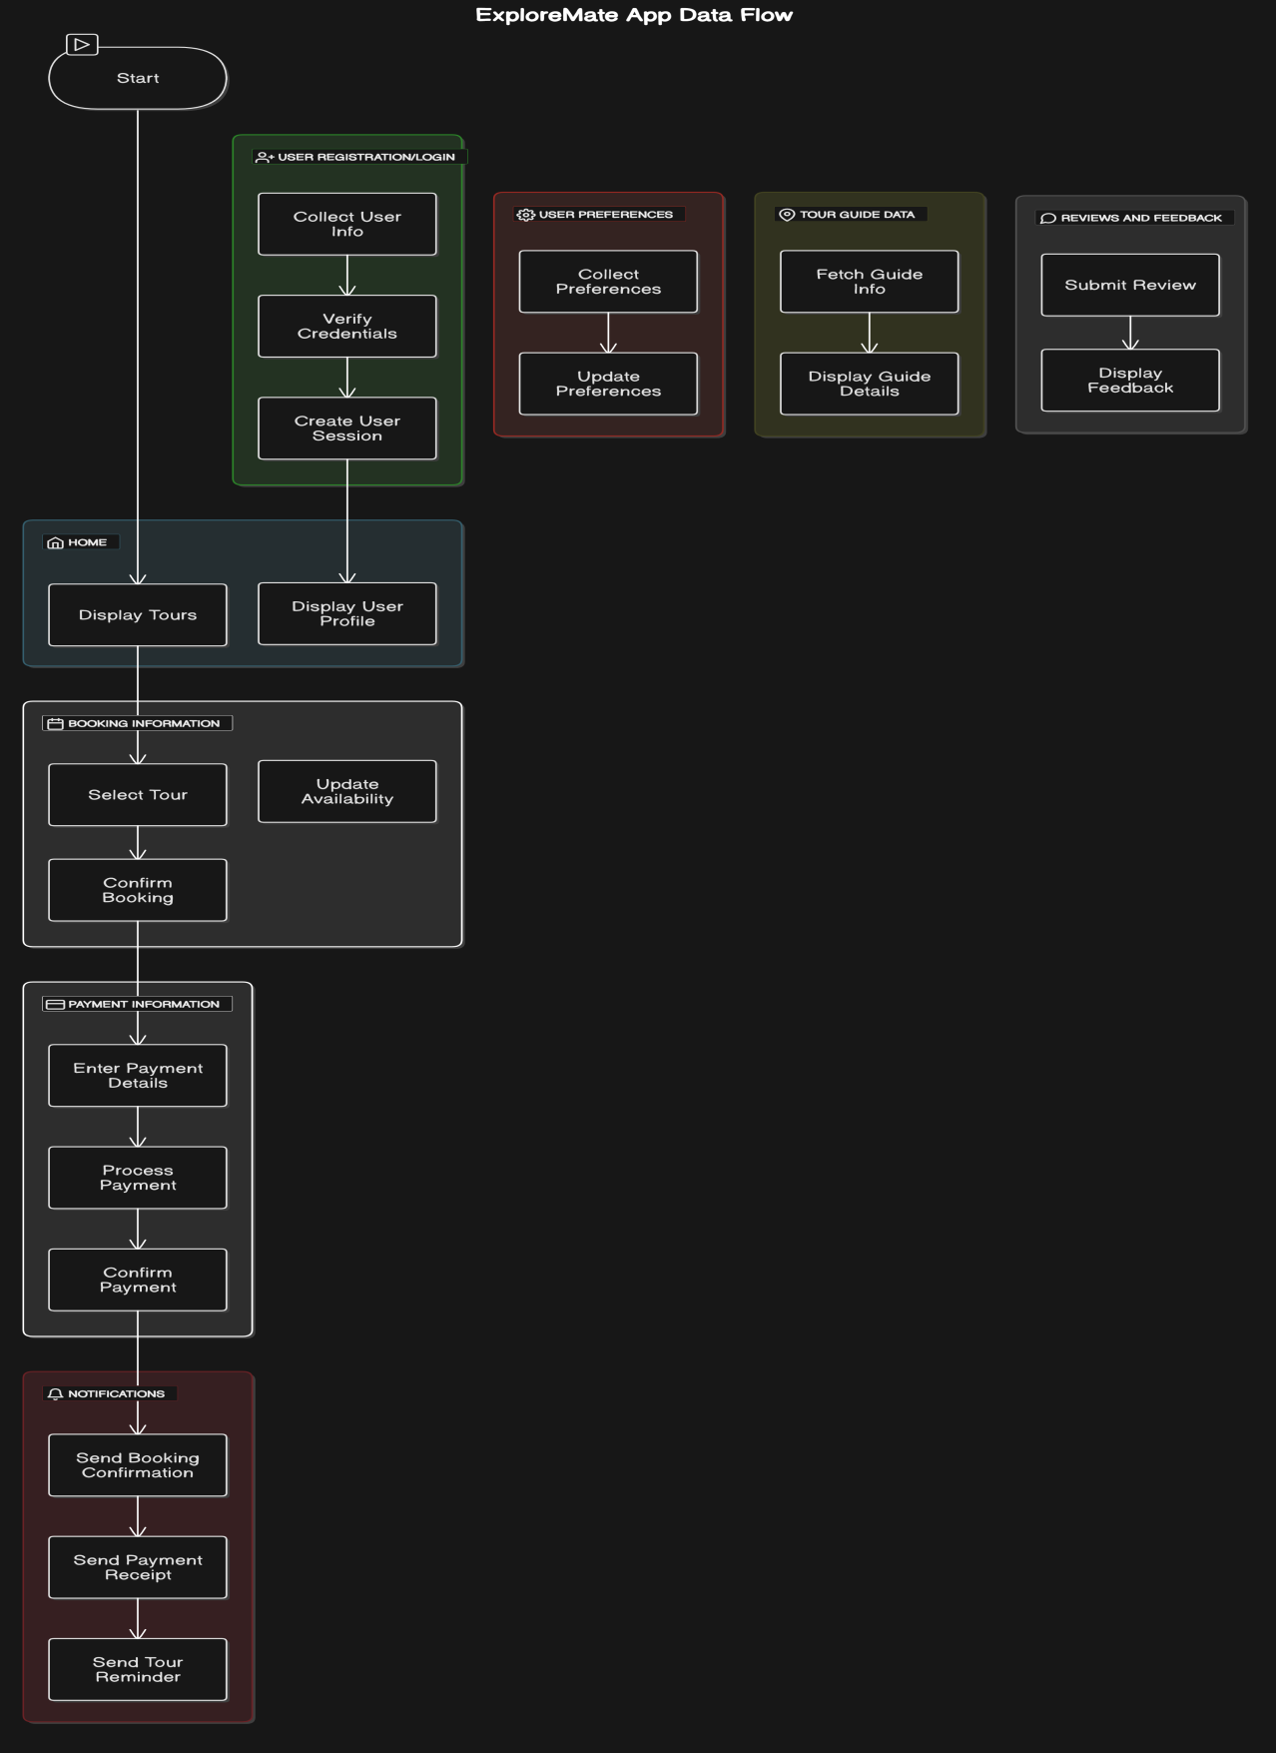

**6.2 ERD**

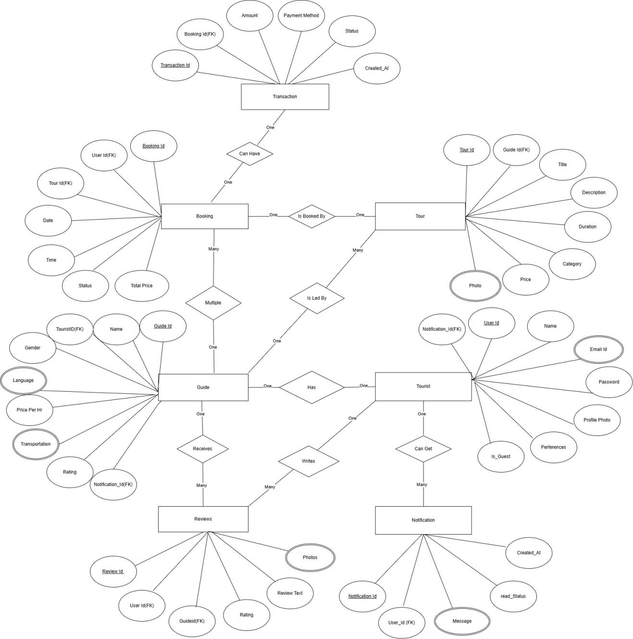

**6.3 Use case diagram**

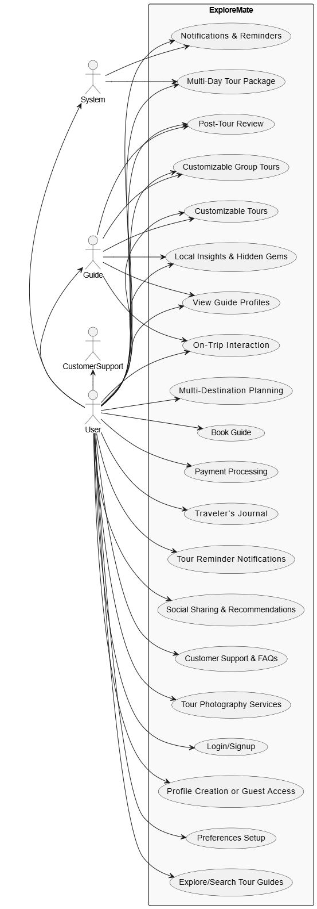

**6.4 Class Diagram**

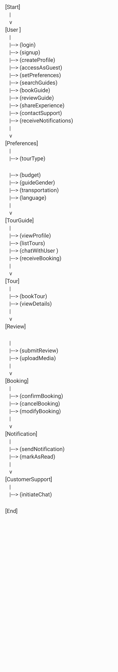

**6.5 Sequence diagram**

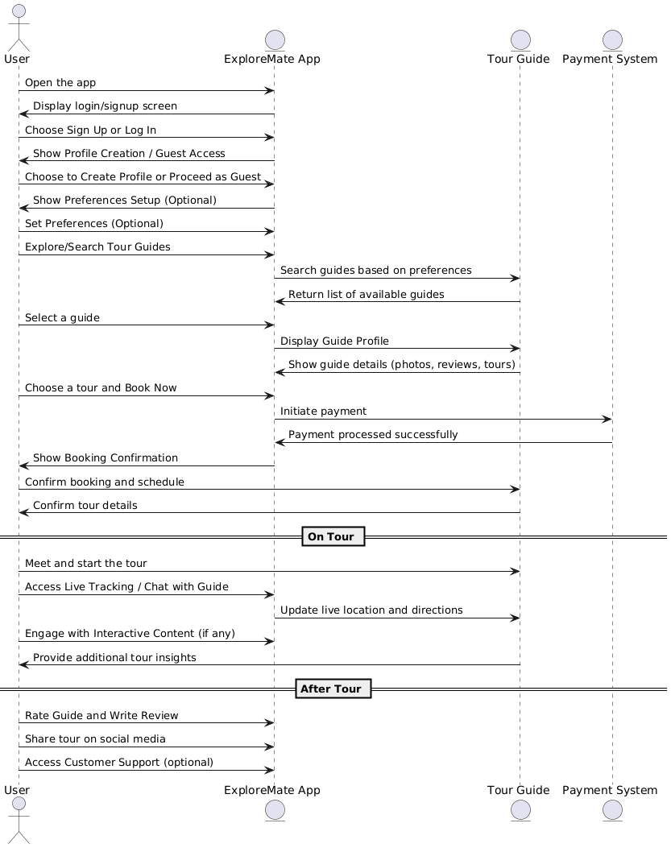

**6.6 Activity Diagram**

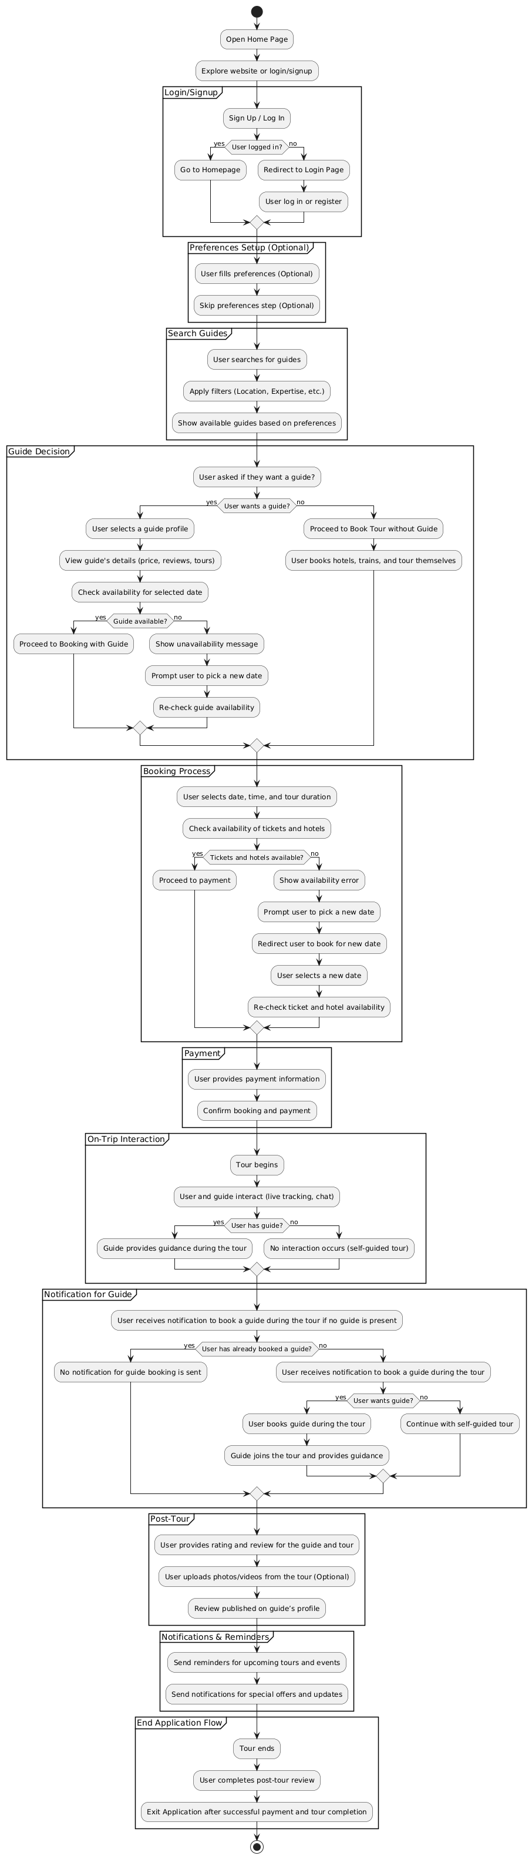

**6.7 Deployment diagram**

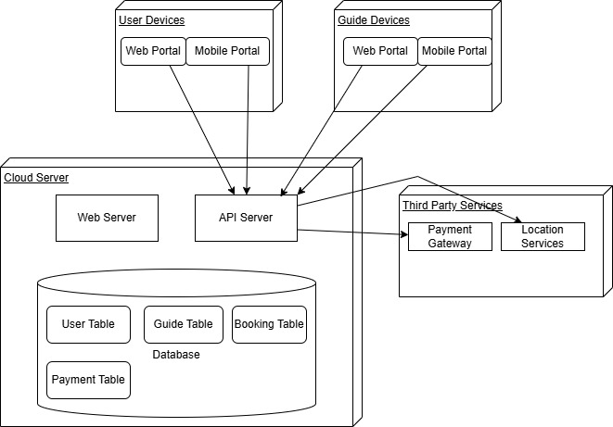

**6.8 System Architecture**

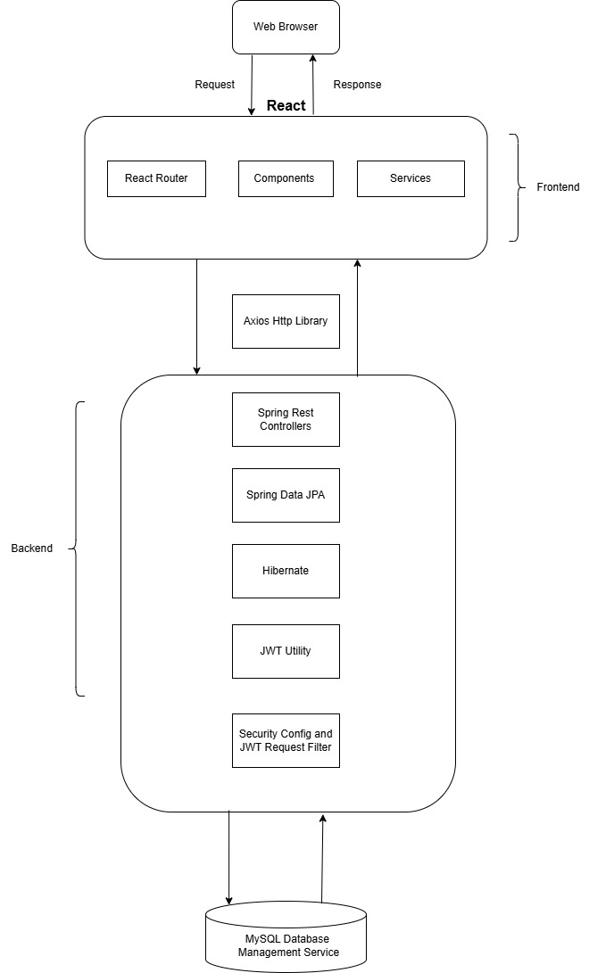

**7 Test Cases**

### ****1. User Authentication and Profile Management****

#### User Registration

* **Objective**: Verify that users can register with valid credentials.
* **Steps**:
  1. Navigate to the registration page.
  2. Enter valid name, email, phone number, and password.
  3. Click "Register."
* **Expected Result**: User is registered successfully.

#### Login with Valid Credentials

* **Objective**: Ensure users can log in using valid credentials.
* **Steps**:
  1. Go to the login page.
  2. Enter registered email and password.
  3. Click "Login."
* **Expected Result**: User is redirected to their dashboard.

#### Login with Invalid Credentials

* **Objective**: Ensure the system handles invalid login attempts appropriately.
* **Steps**:
  1. Enter incorrect email or password.
  2. Click "Login."
* **Expected Result**: Error message is displayed, "Invalid credentials."

#### Password Recovery

* **Objective**: Verify that users can recover their passwords.
* **Steps**:
  1. Click "Forgot Password."
  2. Enter registered email.
  3. Follow the password recovery link sent via email.
* **Expected Result**: User can reset their password successfully.

### ****2. Search and Booking Functionality****

### Search Tour Guides

* **Objective**: Ensure users can search for tour guides using filters.
* **Steps**:
  1. Enter a destination in the search bar.
  2. Apply filters (budget, language, rating).
  3. Click "Search."
* **Expected Result**: Relevant tour guides matching criteria are displayed.

#### Booking a Tour

* **Objective**: Verify the booking process.
* **Steps**:
  1. Select a tour guide and package.
  2. Enter details (date).
  3. Complete payment.
* **Expected Result**: Booking is confirmed, and confirmation details are sent to the user.

#### Canceling a Booking

* **Objective**: Ensure users can cancel bookings.
* **Steps**:
  1. Navigate to "My Bookings."
  2. Select a booking and click "Cancel."
  3. Confirm the cancellation.
* **Expected Result**: Booking is canceled, and refund policy details are displayed.

**8 Screenshots**

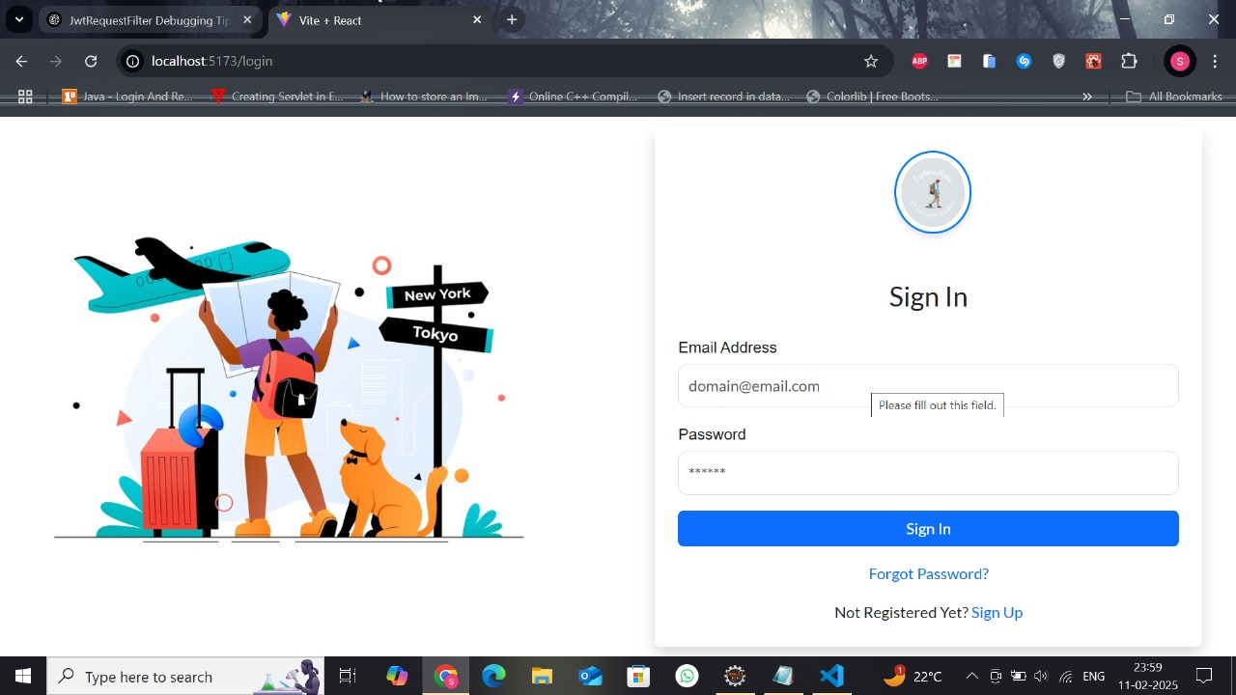

Fig.1 User Login Page

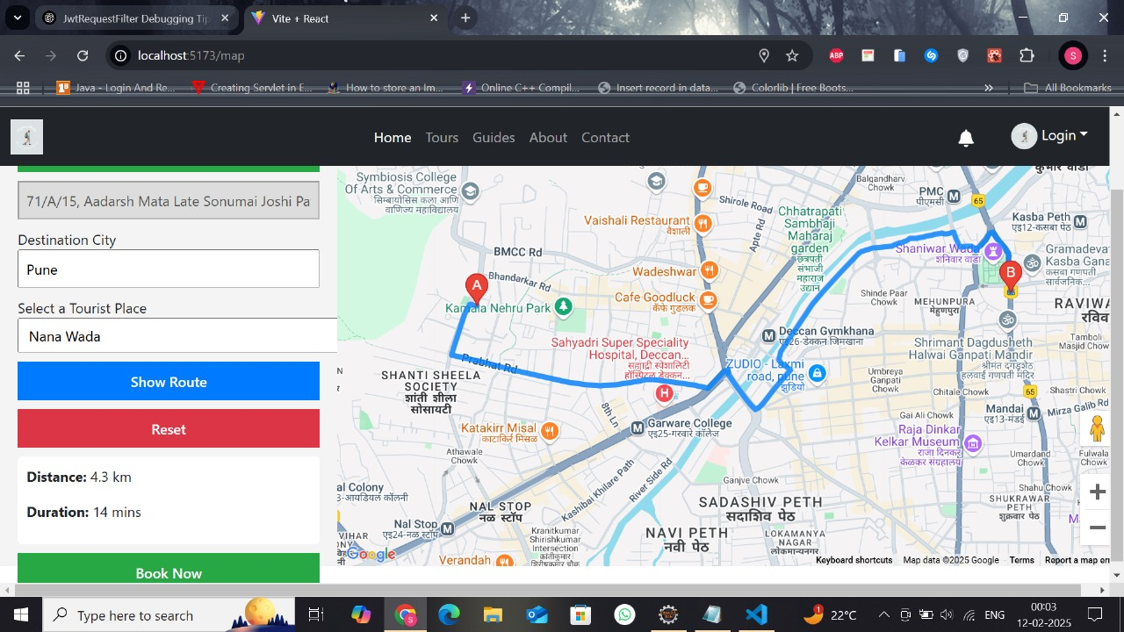

Fig.2 Tour Booking Interface

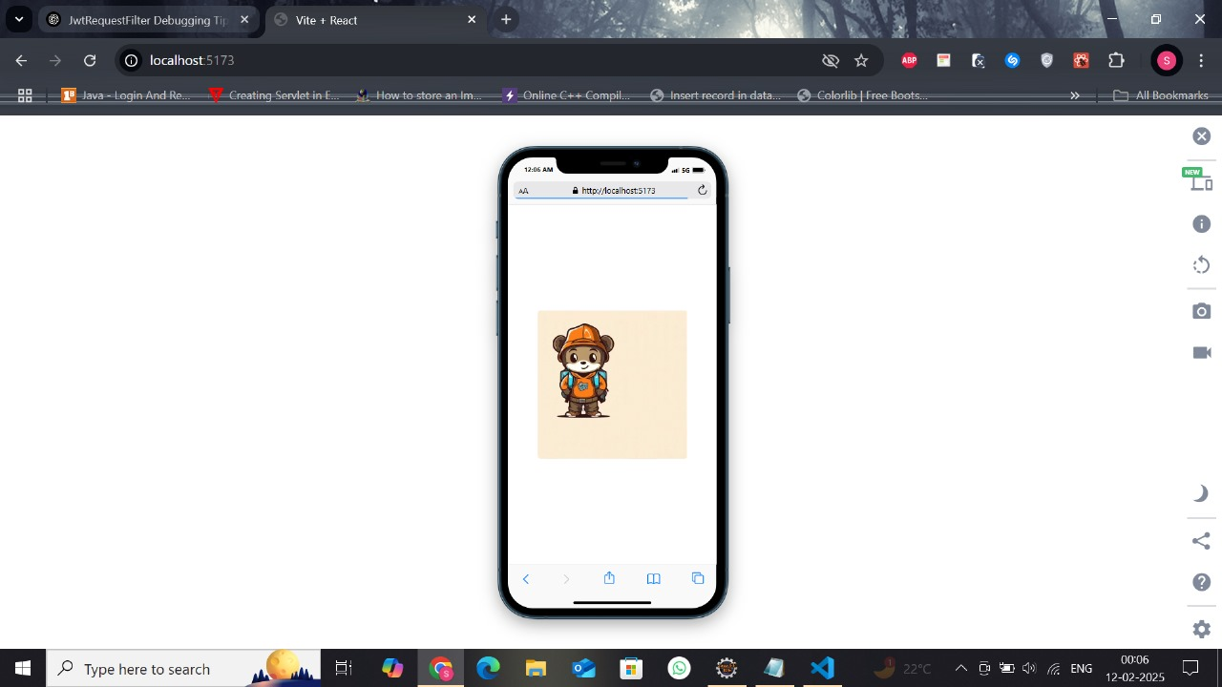

Fig 3. Mobile Interface

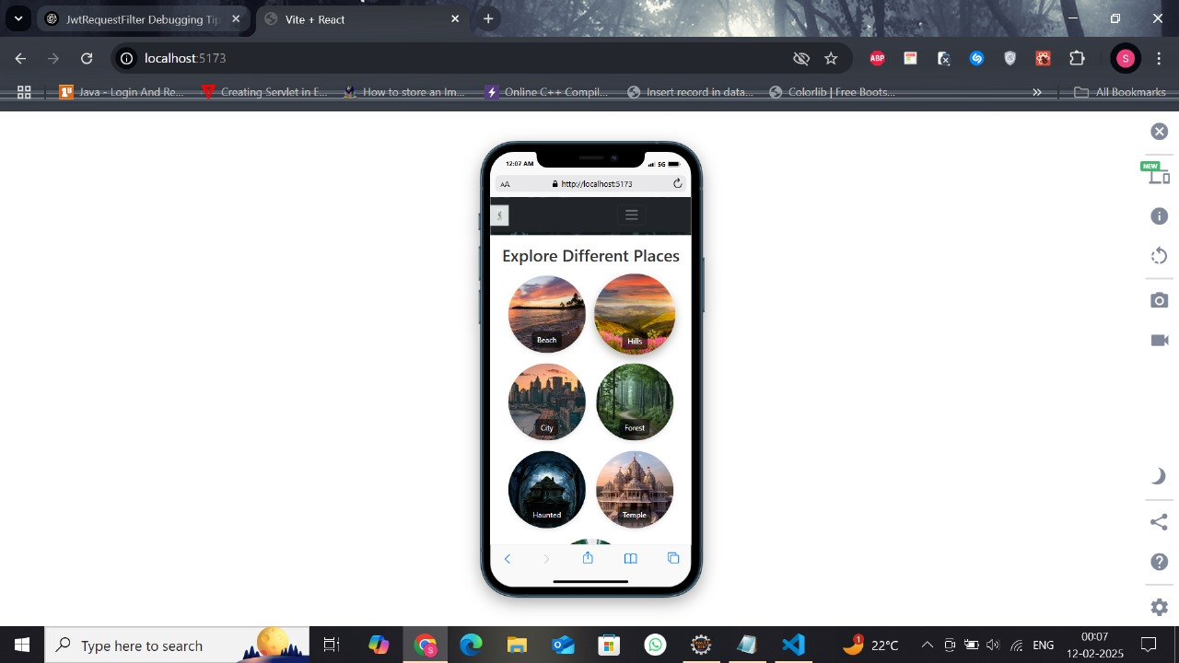

Fig 4. Mobile Interface

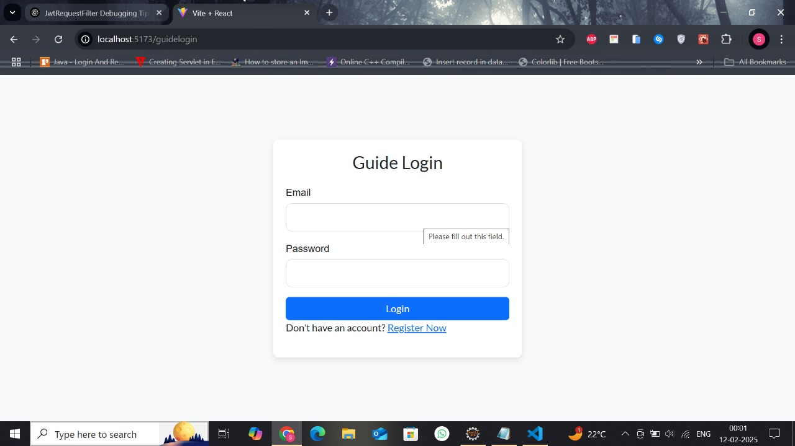

Fig 5. Guide login Page

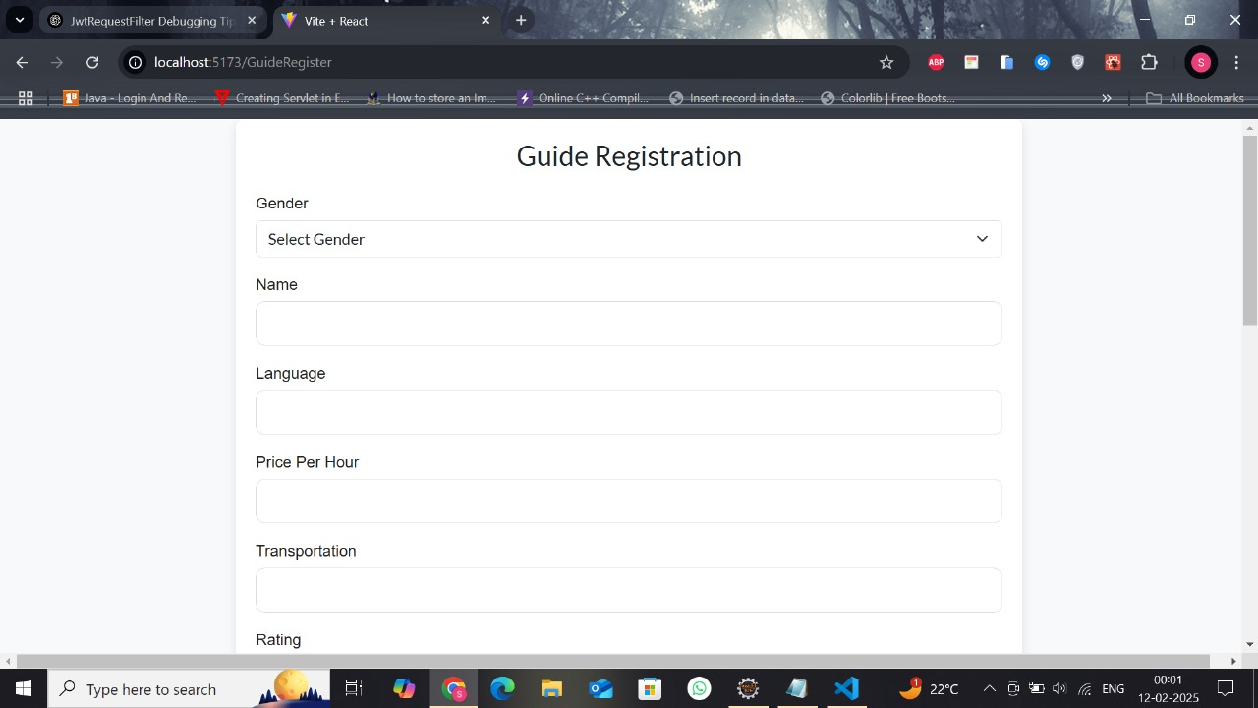

Fig 6. Guide Registration Page

**9 References**

**1.Tour Recommendation System**

Author(s): A. Sharma, R. Kumar

Title: "Smart Tour Recommendation Using Collaborative Filtering and Machine Learning"

Conference: IEEE International Conference on Advances in Computing and Communication, 2021

DOI: 10.1109/ICACC.2021.9456940

**2.Mobile Application Development**

Author(s): J. Tan, L. Li

Title: "A Comprehensive Framework for Cross-Platform Mobile Development Using React Native"

Journal: IEEE Access, Vol. 9, 2021

DOI: 10.1109/ACCESS.2021.3058174

**3.Geolocation and Mapping Technologies**

Author(s): S. Chawla, P. Desai

Title: "Location-Based Services: A Review on Mobile Positioning and Geolocation Techniques"

Conference: IEEE International Conference on Communications, 2022

DOI: 10.1109/ICC.2022.9784156

**4.Emerging Technologies for Sustainable Educational Tourism**Authors: [Kushagra Sharma](https://ieeexplore.ieee.org/author/37085905800); [Adarsh Bharti Musa](https://ieeexplore.ieee.org/author/909669082826618); [Gaurav Singh Mehra](https://ieeexplore.ieee.org/author/37090037431); [Avanish Yadav](https://ieeexplore.ieee.org/author/772922524646166); [Himanshu Rai Goyal](https://ieeexplore.ieee.org/author/37089416932); [Sachin Sharma](https://ieeexplore.ieee.org/author/37085998776).  
Source: IEEE Conference Publication  
Abstract: This paper discusses the application of emerging technologies to promote sustainable practices in educational tourism.  
Link: <https://ieeexplore.ieee.org/document/10392075>

**5.Intelligent Systems for Tourism**  
Authors: [S. Stabb](https://ieeexplore.ieee.org/author/37086979456); [H. Werther](https://ieeexplore.ieee.org/author/37086976701); [F. Ricci](https://ieeexplore.ieee.org/author/37332838700); [A. Zipf](https://ieeexplore.ieee.org/author/37087448896); [U. Gretzel](https://ieeexplore.ieee.org/author/38126089700); [D.R. Fesenmaier](https://ieeexplore.ieee.org/author/37830042300)  
Source: IEEE Journals & Magazine  
Abstract: The study explores the development and implementation of intelligent systems aimed at enhancing various aspects of the tourism industry.  
Link: <https://ieeexplore.ieee.org/document/1134362>

**6.Real-Time Communication Systems**

Author(s): A. Verma, T. Raj

Title: "Real-Time Communication Frameworks for Mobile Applications: A Study of SignalR and WebSockets"

Conference: IEEE International Conference on Software Engineering, 2021

DOI: 10.1109/ICSE.2021.9385678

**7.Government Tourist Information Resource Integration**  
Authors: [Jingjing Guo](https://ieeexplore.ieee.org/author/37087572146); [Xiong Yang](https://ieeexplore.ieee.org/author/37087369404)  
Source: IEEE Conference Publication  
Abstract: This paper examines methods for integrating government-provided tourist information resources to improve accessibility and utility for tourists.  
Link: <https://ieeexplore.ieee.org/document/6258757>

**8.Travel Behavior Analytics**

Author(s): L. Wang, X. He

Title: "Analyzing Travel Behavior Using Big Data Analytics and Machine Learning"

Journal: IEEE Access, Vol. 8, 2020

DOI: 10.1109/ACCESS.2020.2967895

**9.Tourism Data on IEEE DataPort**  
Source: IEEE DataPort  
Abstract: A dataset detailing the travel history of Chinese tourists to Turkey and France, which can be useful for analyzing tourism patterns and behaviors.  
Link: <https://ieee-dataport.org/keywords/tourism>

**10.Accessibility in Mobile Applications**

Author(s): N. Acharya, K. L. Moore

Title: "Designing Accessible Mobile Applications for Diverse User Groups"

Conference: IEEE International Conference on Human-Computer Interaction, 2021

DOI: 10.1109/HCI.2021.9462134

Top of Form

Bottom of Form